Westgate’s Royal Wedding Street Tea Party
Saturday 19th May 2018, 2.00pm - 6.30pm

All residents of Westgate, Henty Gardens, The Tannery, Bartholomew and Tollhouse Close are warmly welcomed to join in the street celebrations for Meghan and Harry’s nuptials.

The street tea party will be held at the city-end of Westgate from 2.00pm. Festivities to include music, Pimms, tea & coffee on tap, children’s games, cake competition and raffle.

Please bring food and drink contributions in keeping with a traditional afternoon tea to share with neighbours, not forgetting a chair to sit on. As with all things Great and British, prizes will be awarded for the most impressive bake-off and the most patriotic attire!

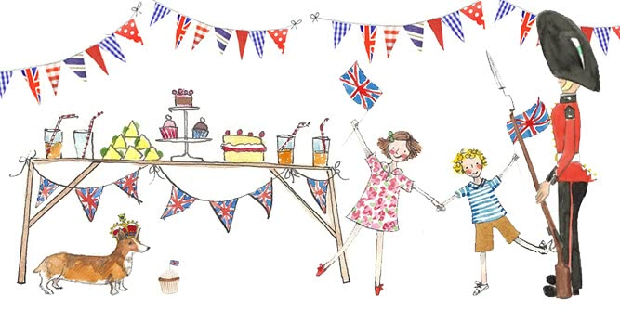

Residents, how can you help?
- Setting-up of gazebos, bunting and tables from 9.30am would be hugely appreciated.
- Clear up at 6.30pm. The street will re-open at 7.00pm and The Crate & Apple will be open as usual.
- Parking. The road from the Westgate roundabout up to Mount Lane will be closed to traffic and all parked cars between 8.30am-7.00pm – please ensure yours is elsewhere.
- Raffle. If you have any prizes that could be donated, please drop off with your RSVP to Nikki.
- Gazebos, if you have one that could be borrowed for the day, please email Brian Raincock, Braincock@cifl.co.uk

------ ✂--------------------------------------------------------------------------------------------

Please RSVP as soon as possible with cash (no cheques please) to: Nikki Clarke, Number 42, Westgate. Cost: £7.50 per adult. Under -18’s no charge.

- Name/s of guests:
- House Number/ Street:
- Email:

